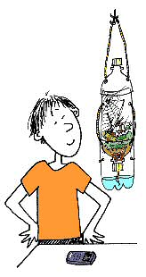
Eco bottle Lab
The purpose of this lab is to set up a viable, self-contained ecosystem with a decomposition chamber (providing nutrients) and an aquatic chamber. You will investigate the changes in the biochemistry and biology of the chambers and evaluate the conditions required for sustainability in the chambers and the interactions between the chambers.
If you would like to include a terrestrial chamber, you can earn bonus points IF everything survives.
You may work in groups up to 4. You may work in groups of less than 4 or by yourself, however—if you choose to work by yourself, you may need to come in before or after school to collect your data because you will not be given additional class time.
Each group will need to provide on _______________
- Five 2-L bottles— clean, clear, colorless, with labels removed and cut according to the directions at the end of this page
- Three bottle lids with holes drilled or burned (you can use a heated nail) according to the directions
- Gravel, marbles, or small rocks—thoroughly rinsed (until the water runs clear)
- An aquatic plant (Elodea, Anacharis or other)
- Grass clippings, crushed egg shells, vegetable or fruit peels (no onion, tomato or citrus) or other organic material for decomposition
- Duct tape
- Freshwater aquatic animal
Fish (beta is recommended), snail, frog
- Small amount of fish food (if you are using a fish—only enough for 1 week)
- If you are doing the optional terrestrial level you will need
  - Terrestrial plant
  - Terrestrial animal—no mammals—(earthworms work well)
  - Food for animal

Teacher will provide for construction day
- Soil
- Screen
- Filter paper
- Prepared water

Procedure:
- Construct the column as shown
- Into the bottom level, place the gravel, water, and aquatic plant
- In the decomposition level, mix your food scraps with the soil provided.
- Place filter paper in the lid and a piece of screen between the lid and the soil mixture
- If you are doing the optional terrestrial level, prepare it as shown on the attached sheet
- Put the precipitation funnel on the top.
- Allow your fish to acclimate to the bottle water by following the teacher’s directions
- After 20 minutes, release your fish into the bottle.

- Download the data sheet to collect the following data:
• temperature of the water
• temperature of the soil
• pH of the water
• fish activity—What is it doing? Does it seem healthy?
• Water quality—is it clear, slightly cloudy, cloudy? Is it colorless or does it have a color to it?
• Fish fed?
• Did you make it “rain”?
• If you did the optional terrestrial level, you need to record the appearance and activity of any terrestrial plant or animals
Every class period thereafter…
- Record all data as listed above. Record the dates, not just day 1, day 2 etc…
- You may not feed your fish after day 4.
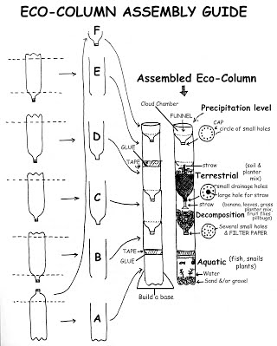
At the end of day one, every person in the group will receive the same daily grade for having the materials here and constructing the eco column correctly and in the time allotted (one class period). At the end of the project, all group members will receive the same lab grade based on the survival and quality of water and life in your eco-bottle. Following the end of the project each person will turn in a typed lab report. You will be given a rubric for grading. This will be an individual grade and will be a test grade.

